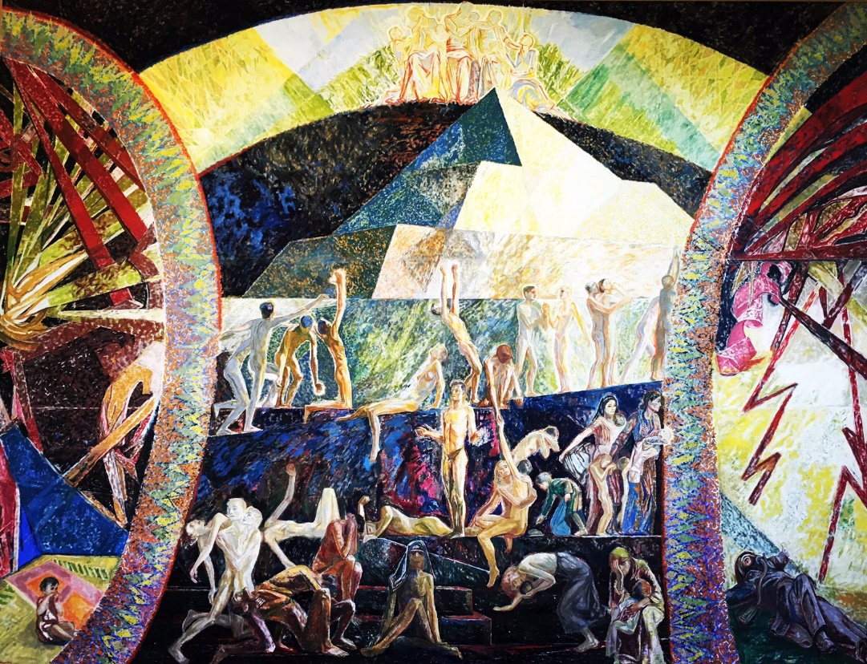
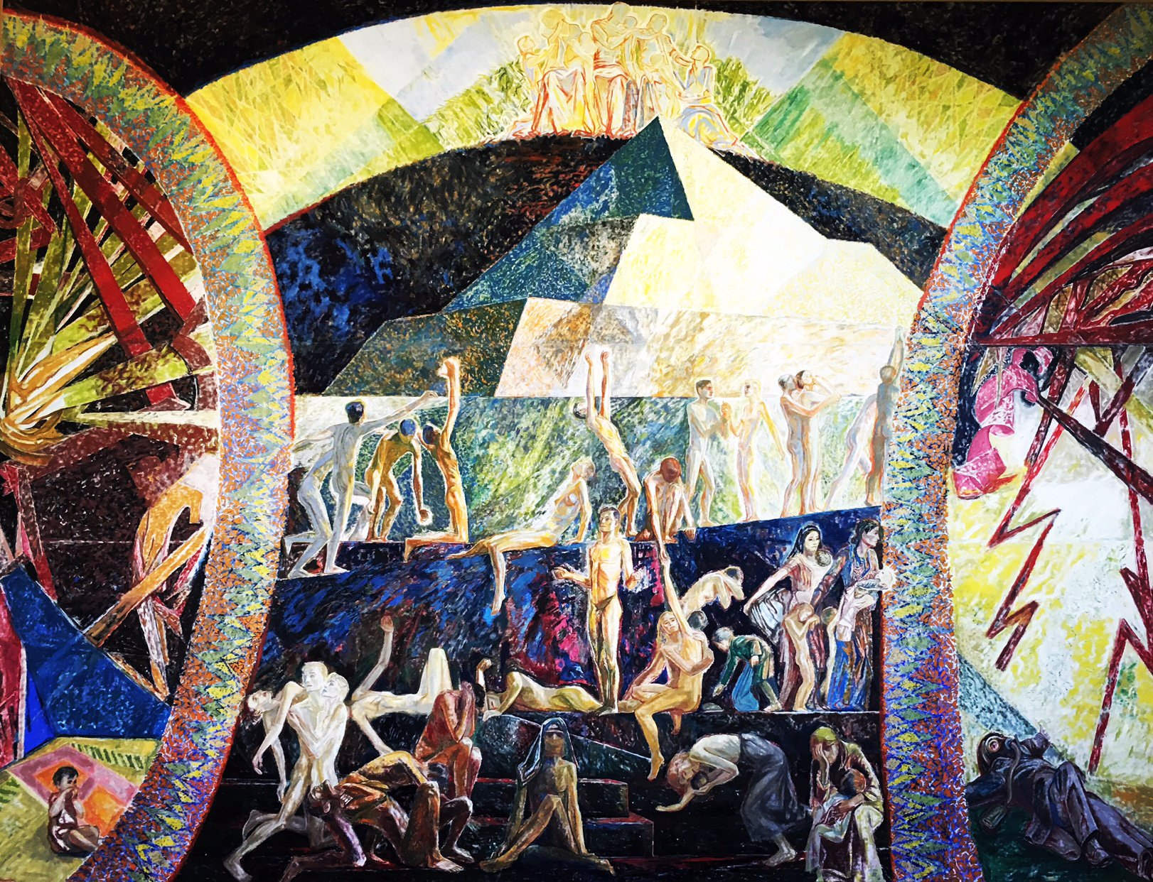
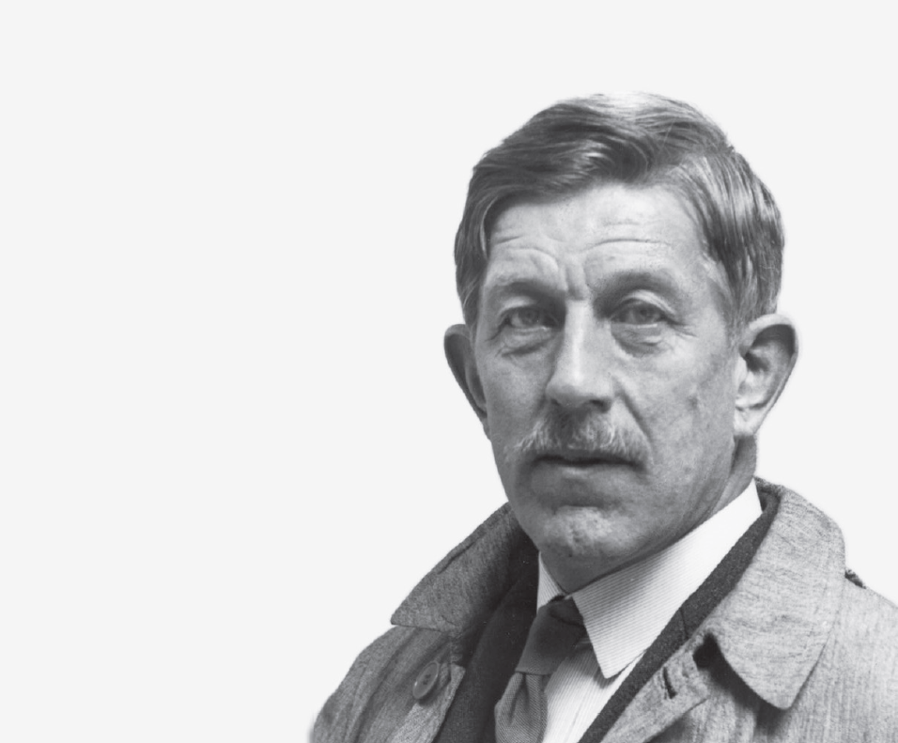
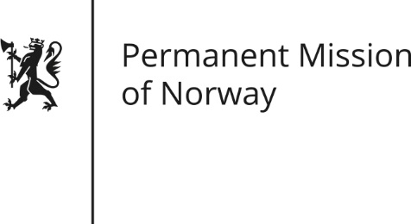

The Dream of Peace
By Henrik Sørensen,
Norwegian painter & pacifist

Norway & a League for peace
The League of Nations was the first international organisation whose principal mission was to maintain world peace. The headquarters of the League was established in Geneva, with the Palace of Nations completed in 1936, decorated by artists from various member states and financed by their respective governments.

Norway became a member in 1920 and played an active role to enable the League to prevent war. One of Norway’s most active representatives and driving forces in the League was the influential statesman C. J. Hambro, elected President of the Assembly of the League in 1939.

Pacifist painter
In 1937 Hambro suggested that the Norwegian state should give the League a large mural in the Palace of Nations. On behalf of the government, Halvdan Koht, Norway’s Minister of Foreign Affairs (1935 – 1940) gave Sørensen the task of making the mural. The artist got to work at once and the painting was finished two and a half years later.

Sørensen was one of the most prominent figures in Norwegian cultural and social life. He was not only an appreciated painter with a manifold and varied collection of works, but also strongly engaged in political questions and known to be a radical pacifist. For several decades he fought against armament and war and publicly supported the League of Nations.

“During the interwar years Sørensen had an uncompromising pacifist attitude. He gave lectures, organised antiwar exhibitions, wrote articles and engaged in polemics. When the Second World War broke out on 1 September 1939, all this work seemed to be in vain, and one might believe that the disappointment would be devastating for him and his like-minded. But my father did not give up. At the center of his pacifist activity was his credo: ‘The light from the Nordic countries’… The Nordic countries shall create the new positive peace movement…”

- Extract from Sven Oluf Sørensen’s biography of his father,2003

The Dream of Peace
Henrik Sørensen made a painting 8.6 meters wide and 6.5 meters tall – 56 square meters – and gave it the title “The Dream of Peace”. It was painted on canvas and exhibited in the House of Artists in Oslo in November 1939, before being rolled up and brought by train to Switzerland. World War II had already started, and Henrik Sørensen and his son Sven Oluf travelled through a blacked-out Europe. In Geneva, the picture was mounted in the Palace of Nations, in a room suited for calm contemplation.

The mural covers the back wall of the library hall and was inaugurated in December 1939 with Hambro as President of the League. The media at the time asked Sørensen if he was not worried that he might seem ridiculous with his message of peace in the middle of a war situation. According to his son, the painter replied: “Oh yes, but I do not know who is most comical: I, having believed in a kind of ascending sunrise for humanity, or those who are content to be swallowed by the ascending darkness.”

Description by the artist
“The Dream of Peace! The left part of the picture provides an image of the totalitarian war. A home in happy blue, rose and green colours. The child sits in the middle. All this is splintered by the war. To the right, the human being as a uniformed machine, in the position of Golgotha. These two images of destruction create the dream and demand for the millennium – the definitive peace. The two arcs created by the colours of these two areas have a form based on the ornamentation of light. At the top of the picture the arcs create an area with the mothers of five continents and their children, symbolising peace.

The central motif is the pyramid, symbol of the ancient ascending principle. At the bottom are the defeated people, the unhappy mothers with their children. In the middle sits the oriental woman – but with a dash of blue hope over her bloody headdress. To the left are the two human birds, the “Paolo and Francesca” of the time – the humans clutching to one another in hard times.

In the axis of the pyramid the new human being rises with the shadows from the level of destruction of the picture. To the right, the persecuted people, refugees and children of famine – but in the green colour of hope. In the middle level of the pyramid the colour of light and darkness meet.

In the aftermath of the encounter in the battle between the dark and the absolute victorious light the human beings are awakened, rise and go up to the light. To be able once…to meet the dream and the definitive peace.”

Henrik Sørensen, October 1939
Henrik Sørensen (1882-1962), an important artist in Norway in the 20th century, was the obvious choice when the Norwegian government at the time decided to contribute to the decoration of ‘Palais des Nations’. He was actively involved in social issues, worked for peace during the interwar period and supported the League of Nations. His painting “The Dream of Peace” was donated by Norway in December 1939, at a very precarious time in world history.

This leaflet is published by the Permanent Mission of Norway to the United Nations in Geneva in close collaboration with Ms Torild Skard, a family friend of Sørensen, 21.09-2018.

This leaflet is published by the Permanent Mission of Norway, in close collaboration with Ms Torild Skard, a family friend of Sørensen.

